Web Programming
Lab Assignment 14

By: Avyakth Shriram (24BCE5461)

LAB 14 – HTML Code:

<!DOCTYPE html>
<html lang="en">
<head>
<meta charset="UTF-8">
<meta name="viewport" content="width=device-width, initial-scale=1.0">
<title>Detach Event Listener</title>
<link rel="stylesheet" href="styles.css">
</head>
<body>
<h1>Detach Event Listener</h1>
<p>This page shows how an event listener can be attached to an element and then removed.</p>
<button id="actionBtn">Click To Demonstrate Listener Status</button>
<button id="listenerBtn">Click To Attach Listener</button>
<div id="log"></div>
<script src="script.js"></script>
</body>
</html>

LAB 14 – CSS Code:

body {
font-family: Arial, sans-serif;
margin: 2rem;
}

button {
margin-right: 1rem;
padding: 0.5rem 1rem;
font-size: 1rem;
cursor: pointer;
}

#log {
margin-top: 1.5rem;
border: 1px solid #ccc;
padding: 1rem;
max-height: 200px;
overflow-y: auto;
background: #f9f9f9;
}

#log p {
margin: 0.25rem 0;
}

LAB 14 – JavaScript Code:

// Attach an event listener to action button
const actionBtn = document.getElementById('actionBtn');
const listenerBtn = document.getElementById('listenerBtn');
const logDiv = document.getElementById('log');

function handleActionClick() {
const msg = 'Button clicked at ' + new Date().toLocaleTimeString();
const p = document.createElement('p');
p.textContent = msg;
logDiv.appendChild(p);
}

function handleListenerClickAttach() {
actionBtn.addEventListener('click', handleActionClick);
listenerBtn.textContent = "Click To Detach Listener";
const p = document.createElement('p');
p.textContent = 'Listener attached';
p.style.fontStyle = 'italic';
logDiv.appendChild(p);
}

function handleListenerClickDetach() {
actionBtn.removeEventListener('click', handleActionClick);
listenerBtn.textContent = "Click To Attach Listener";
const p = document.createElement('p');
p.textContent = 'Listener detached';
p.style.fontStyle = 'italic';
logDiv.appendChild(p);
}

var state = 0;

// When the listener button is initially pressed we attach the listener, when pressed again we detach the listener, and so on and so forth. We also log the current state of the listener in the log div.
listenerBtn.addEventListener('click', () => {
if (state == 0) {
handleListenerClickAttach();
state = 1;
}
else {
handleListenerClickDetach();
state = 0;
}
});

LAB 14 – Screenshots:

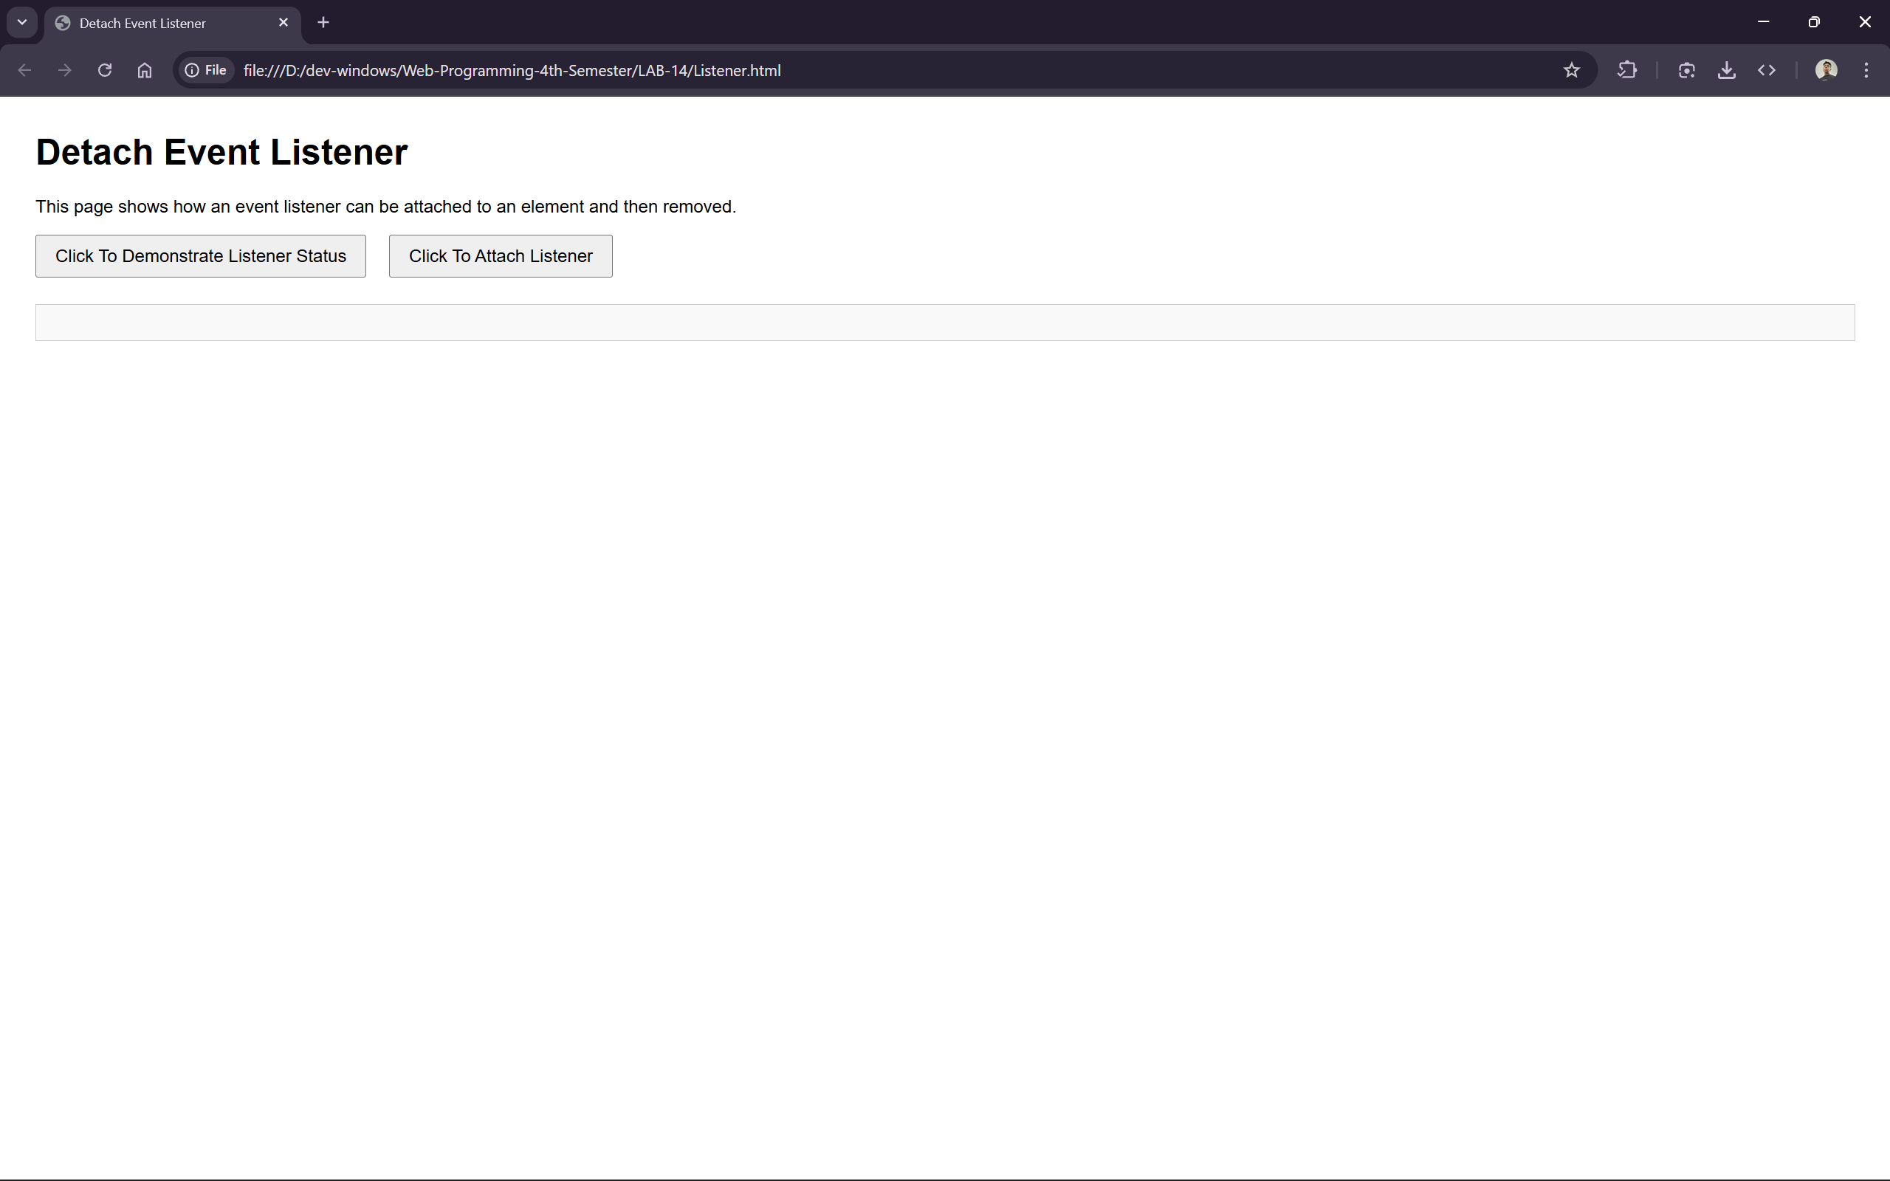

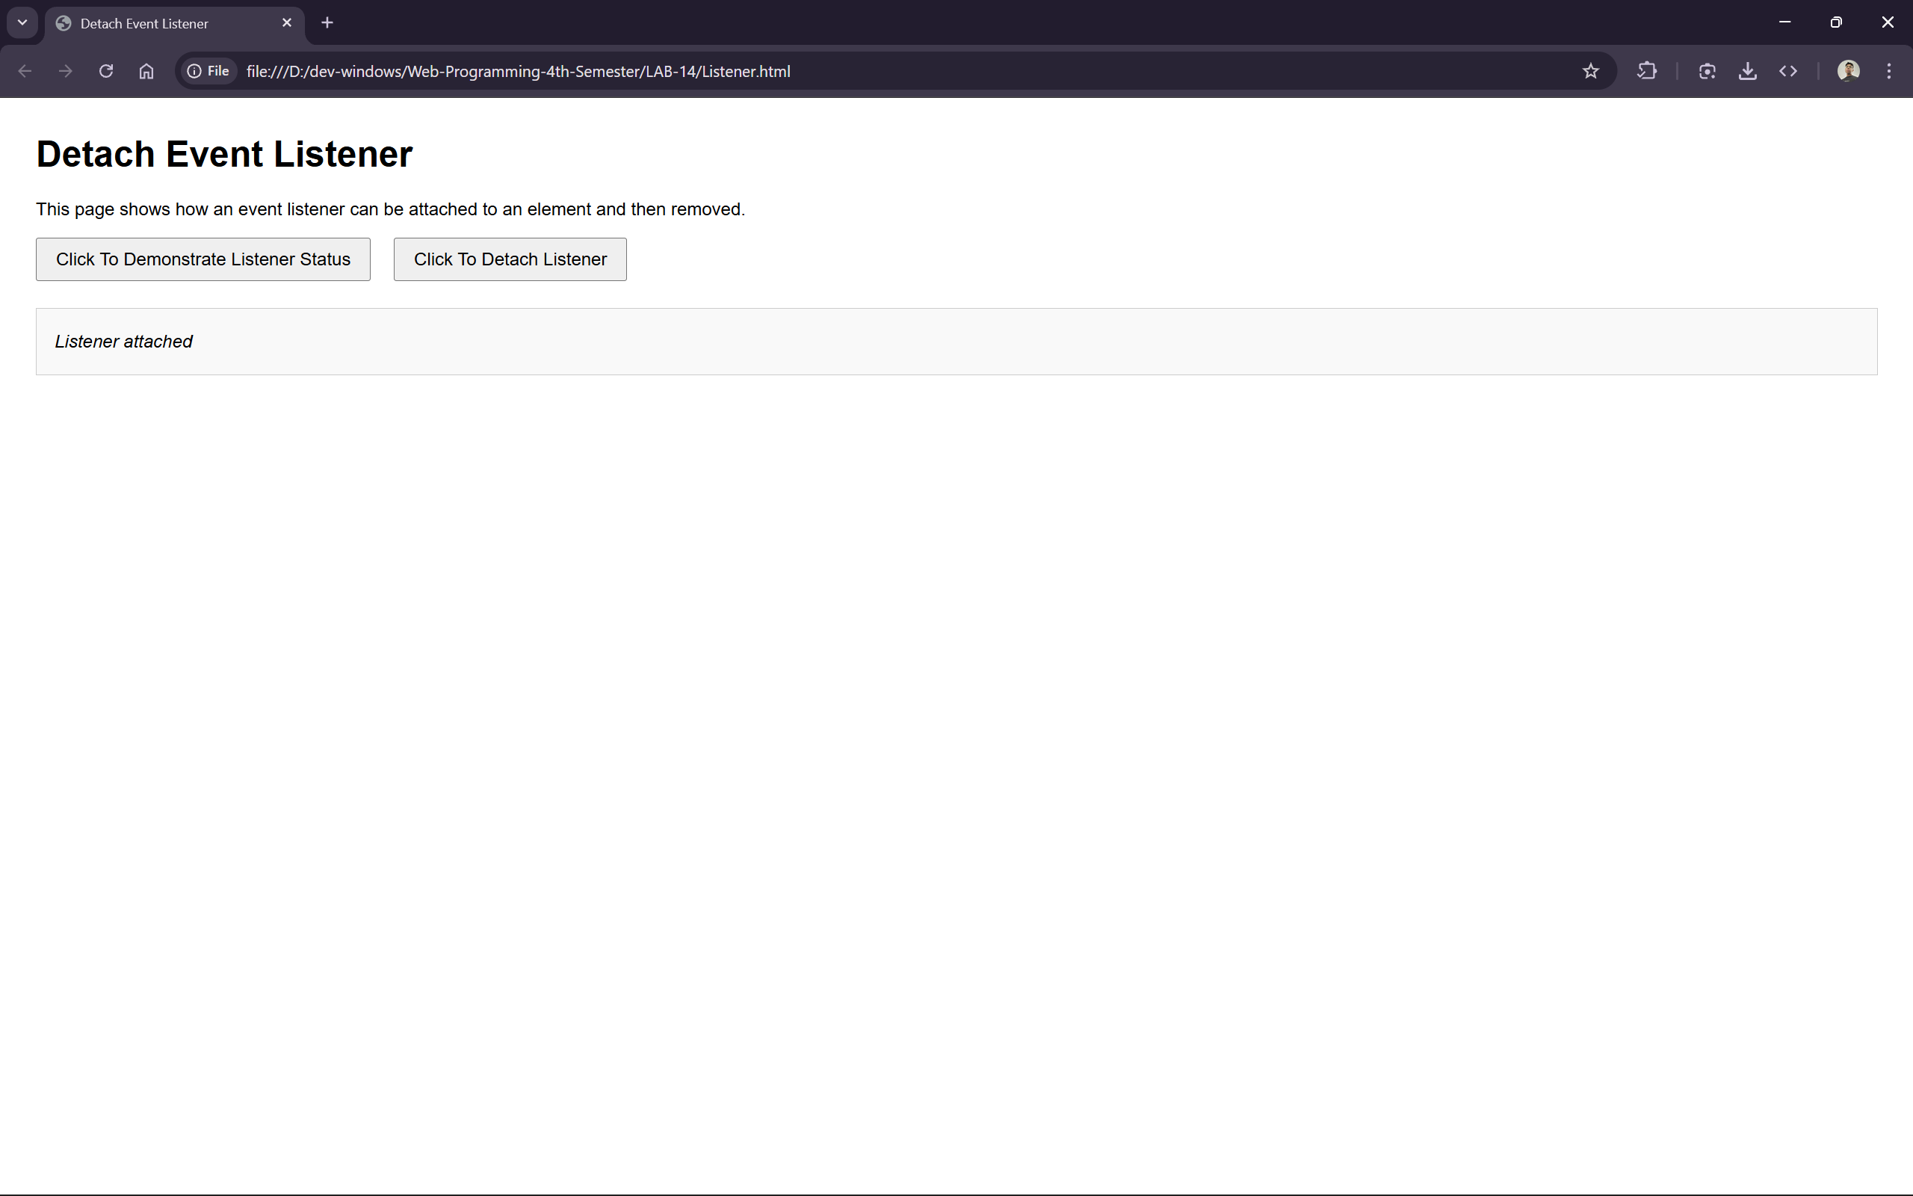

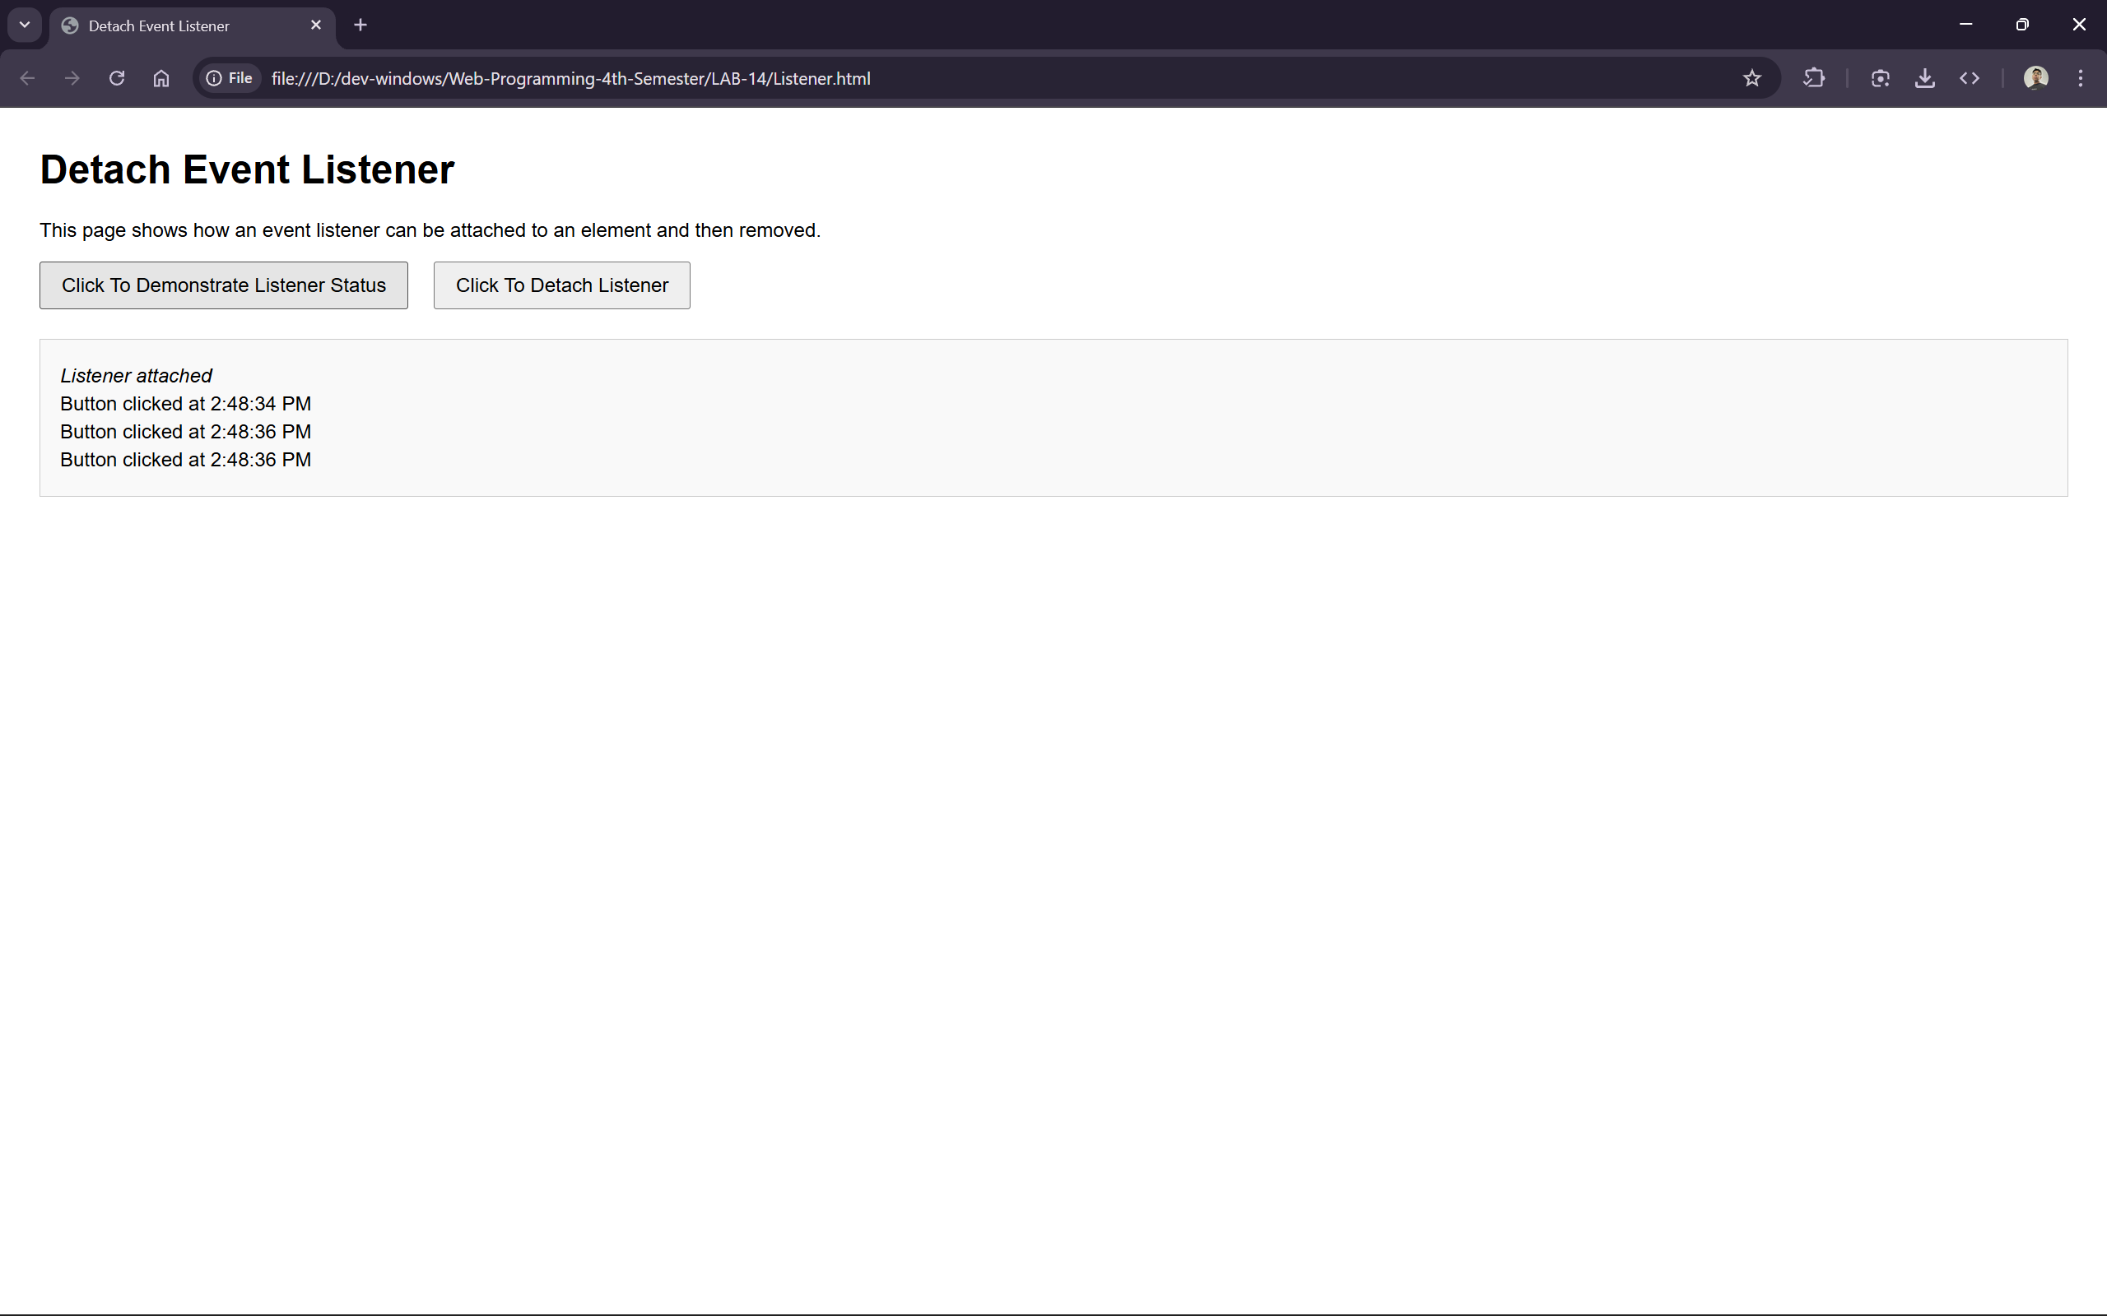

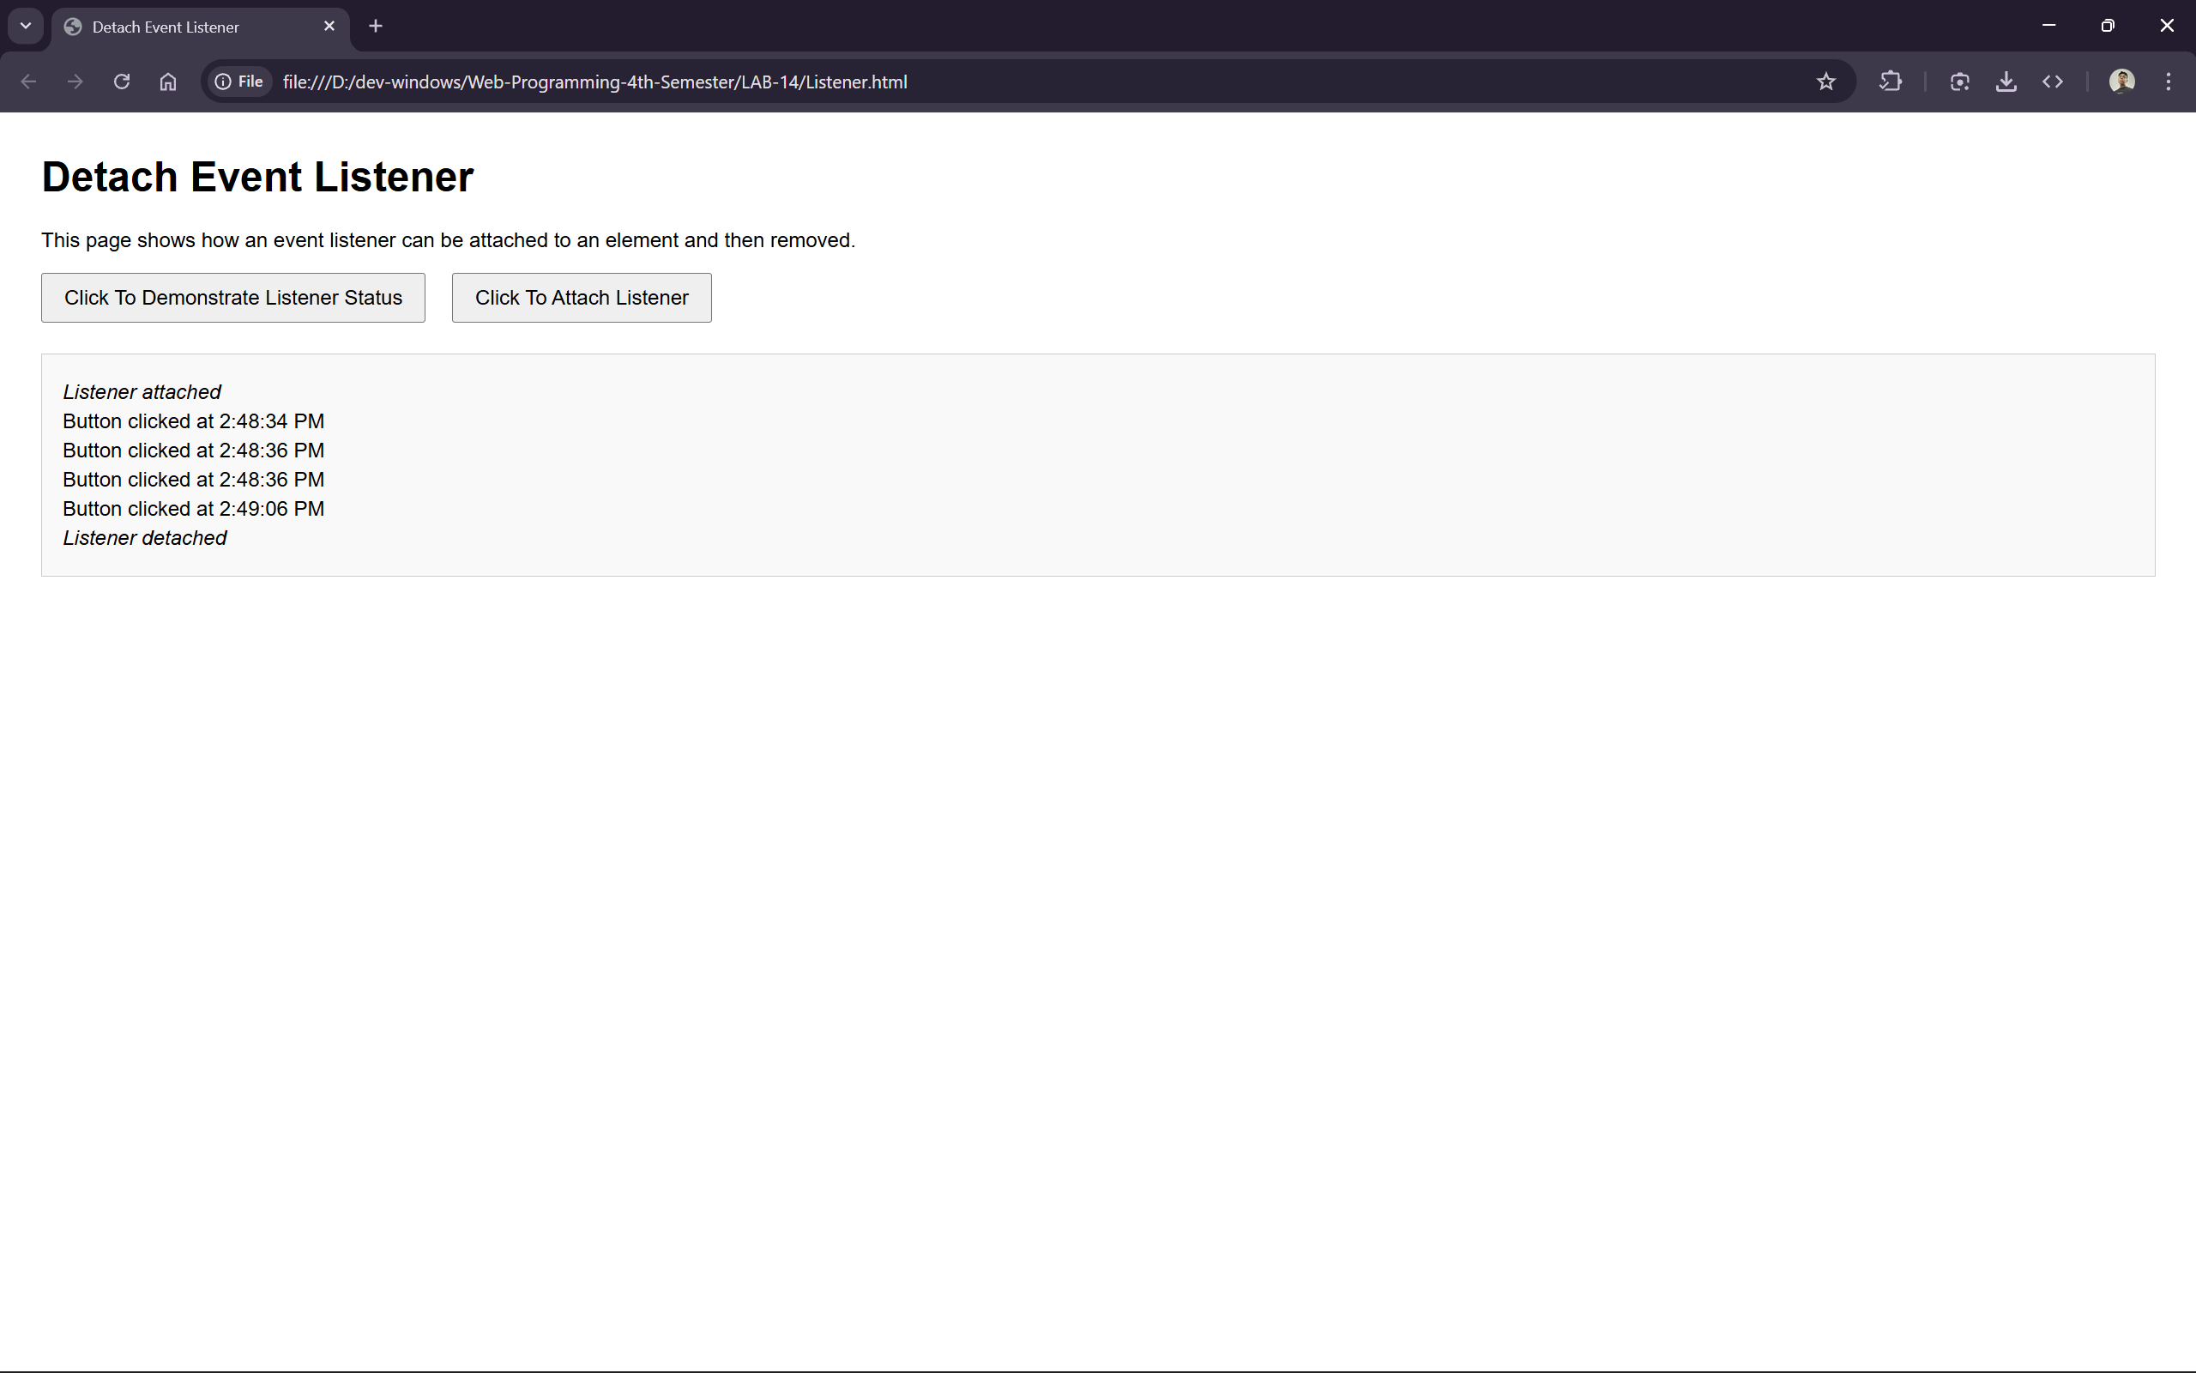

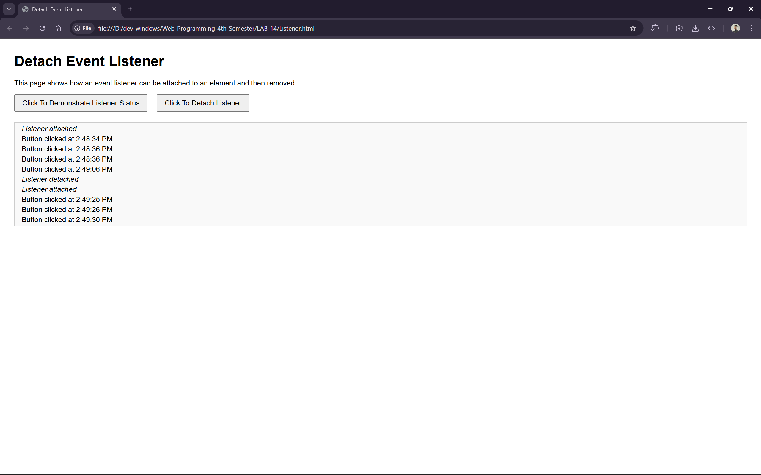

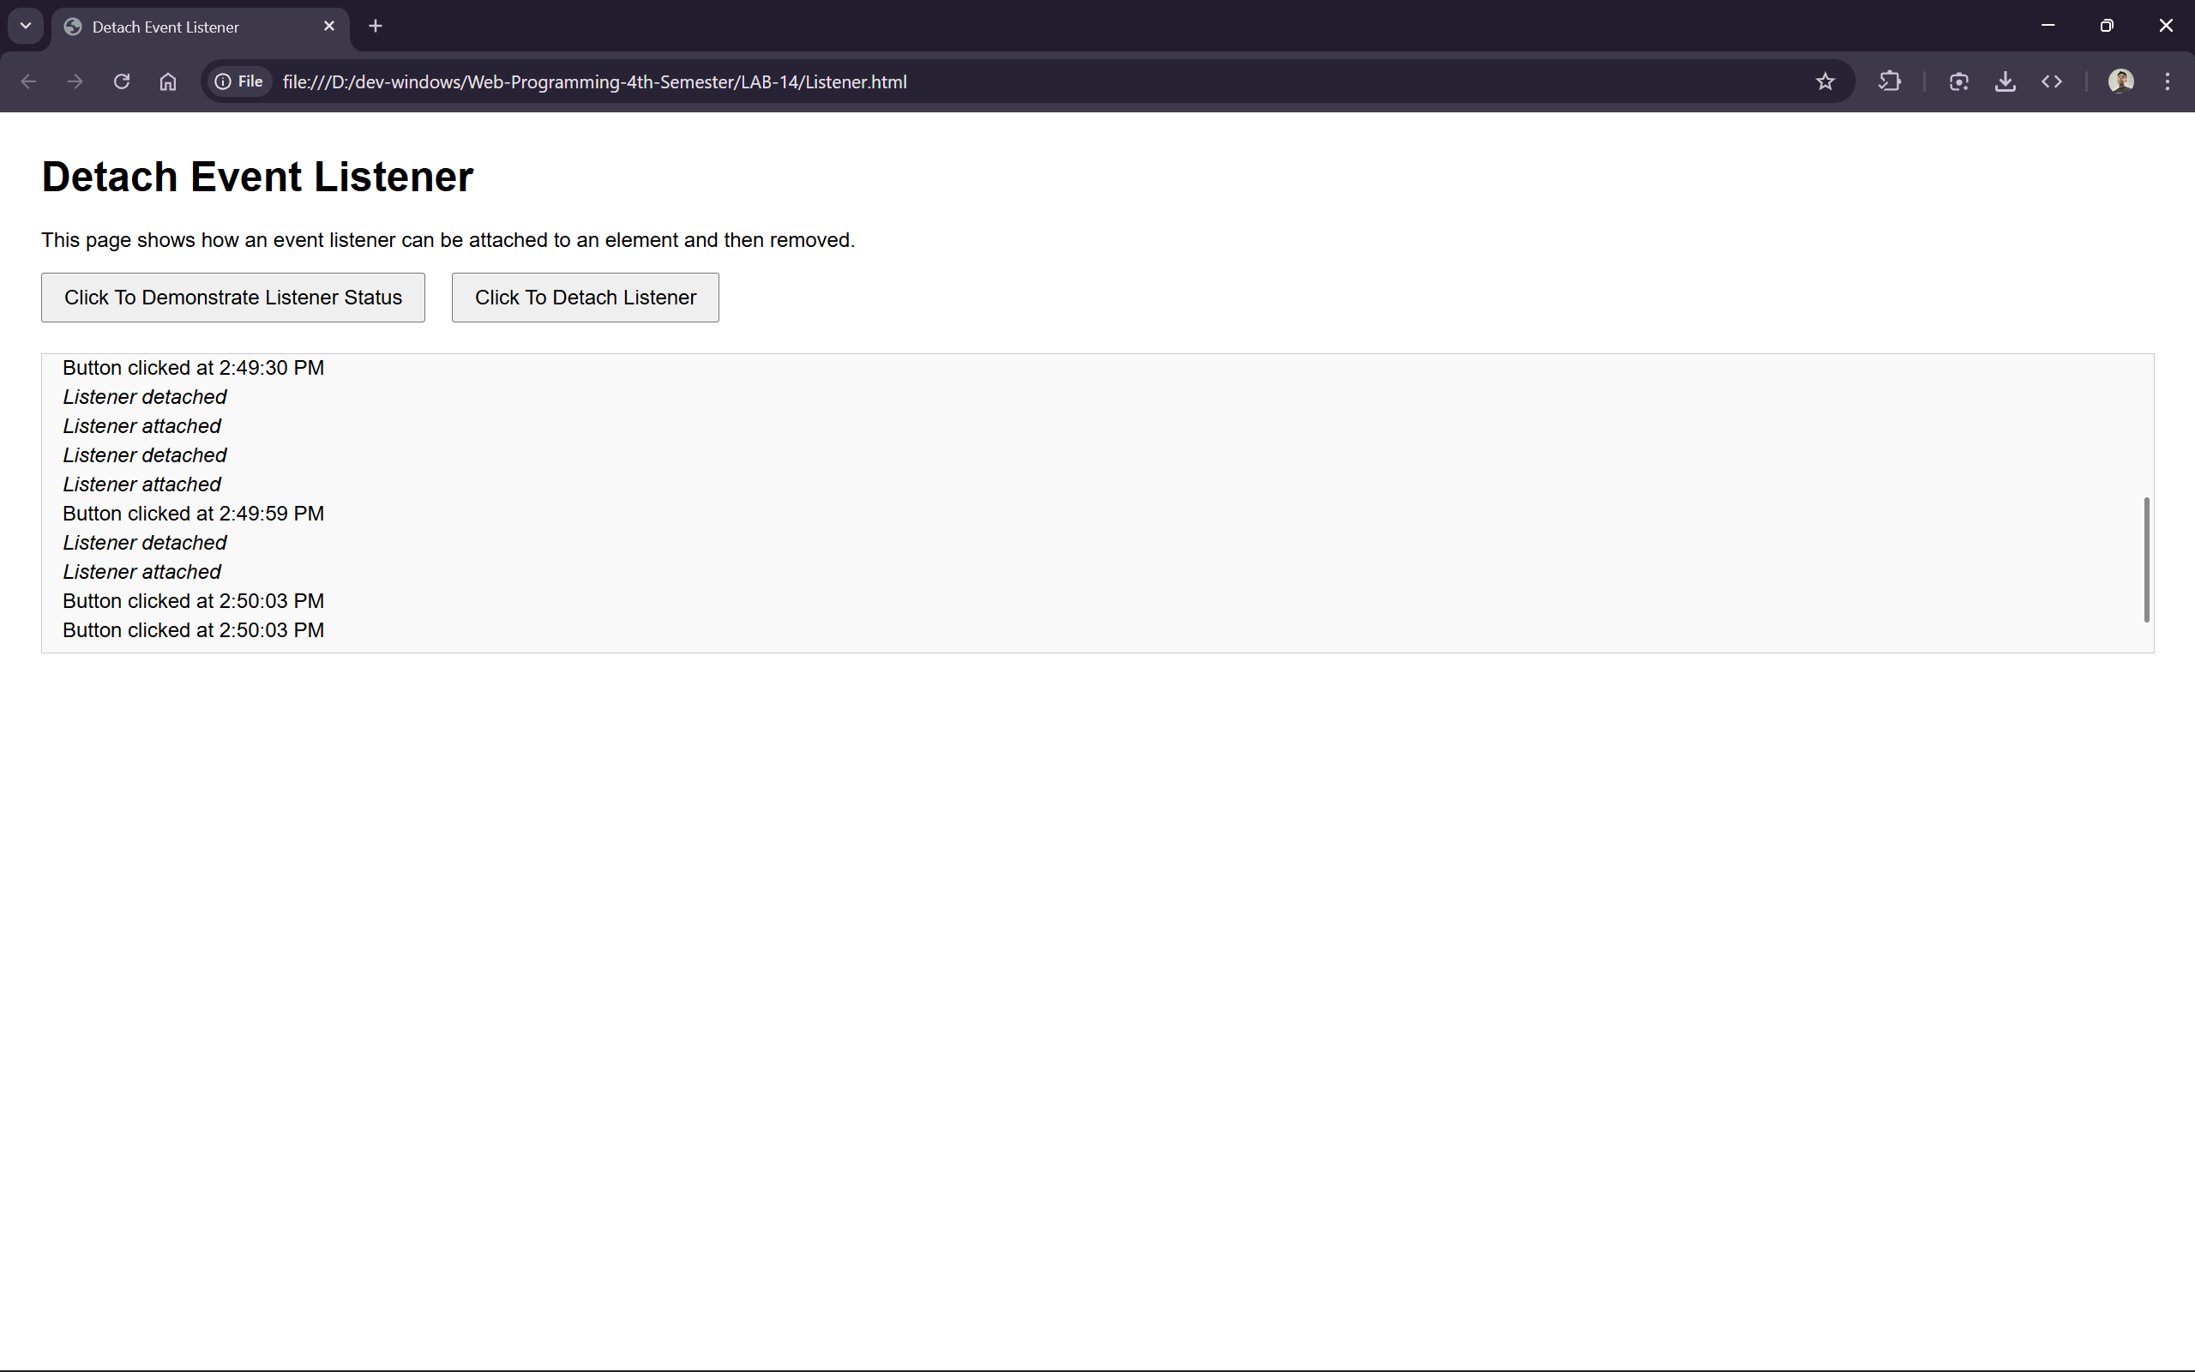

THANK YOU!!!

